Practical 20 Tabbed Panes and Tables

- Using WindowBuilder create the following application. I started this class by selecting File| New |other |WindowBuilder| JFrame
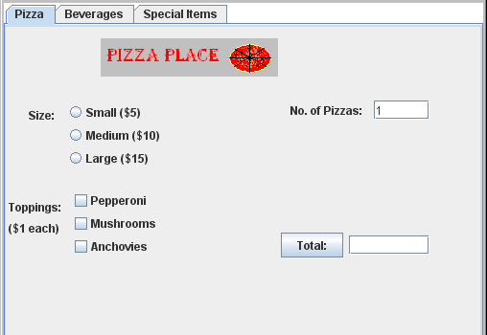

Create a Tabbed Pane
- Set the contentPane to Absolute Layout. Drop a JTabbedPane from the Component Palette onto the Design View:
Resize it appropriately.
- Drop a JPanel onto the JTabbedPane — the first tab appears:
Drop the next JPanel onto the Frame but drop it high; right beside the tab label. Look at the tab properties to change the title and order.
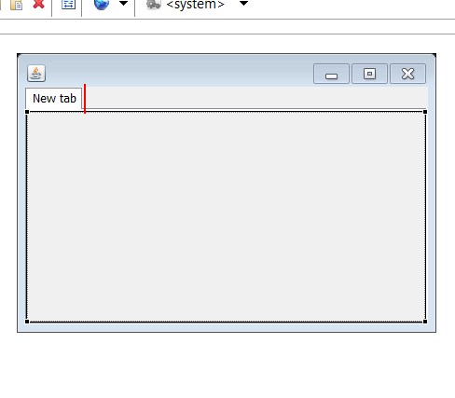
Seeing images in the icon property:
Paste the image into your package (does not work if you use a default package)
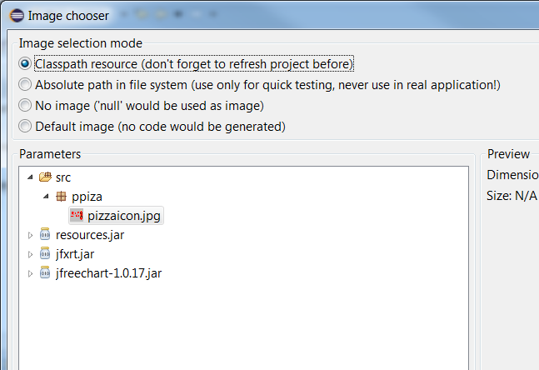
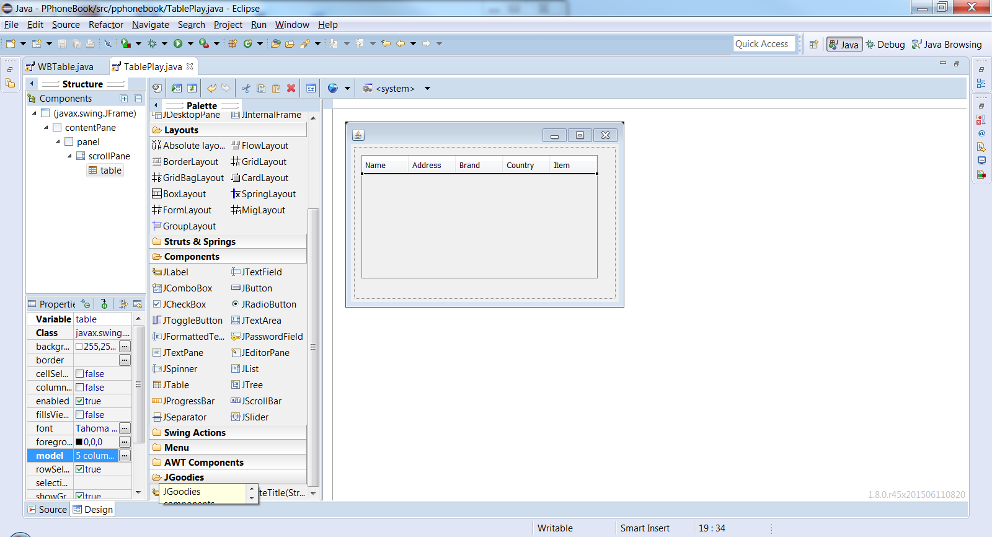
Creating a JTable –note the components needed

Hint: right click on your table
and surround with a scrollPane

If you can’t edit the table model in Design view to create the column headings just hard code it (this is in the constructor)

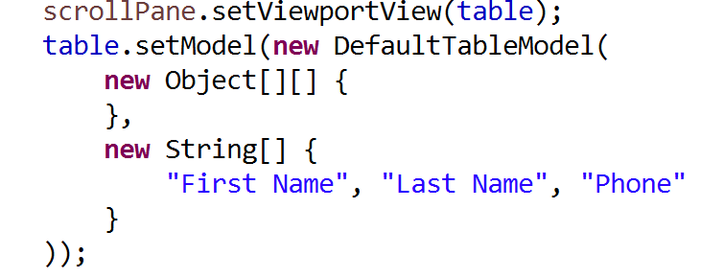
Notice the annoymous table model! I need its name so rewrite declaring it as a class property

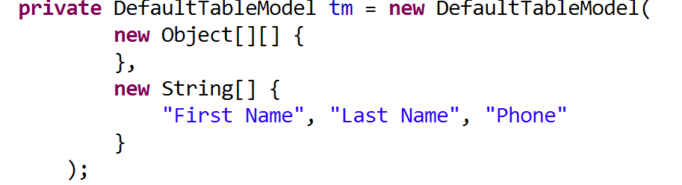
Set the table model and draw the table
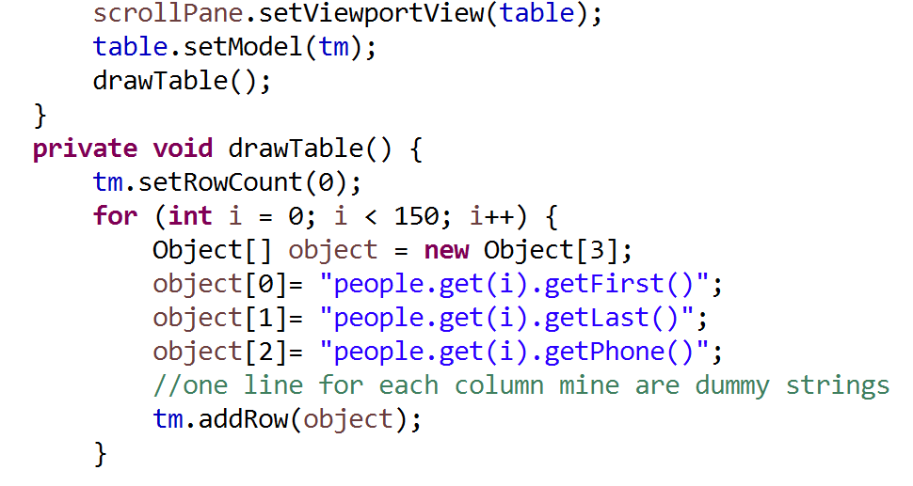
constructor

